12129 Faulkner Drive
Owings Mills, MD 21117 MitchellW@solomon-berlmedia.com 443.334.5132

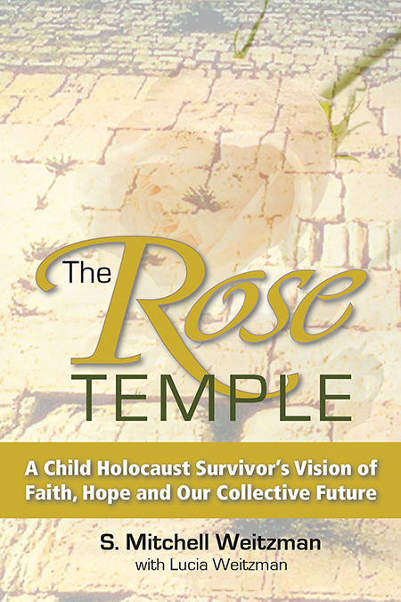

The Rose Temple –
Selected Reviews
Midwest Book Review
Diane Donavan, Senior Reviewer

The Rose Temple: A Child Holocaust Survivor's Vision of Faith, Hope and Our Collective Future blends history and memoir with a social plea as it follows a woman who not only survives the Holocaust, but becomes a spiritual messenger.
Lucia Weitzman's transformation began with her struggle to survive both physically and spirituality: a journey through turns of events that take readers far from the usual Holocaust autobiography about surviving atrocities. The story is told by her son, Mitchell Weitzman.
It was after the author's father died that his mother's spiritual exploration began ("Her friends and family expected her to seek security and comfort with a companion. Instead she chose to spend her time documenting her mystical dreams and visions in a private journal.") in a quest that will eventually draw him into what was to prove an incredible journey for them both as son and mother drew together in unexpected new directions: "I began writing The Rose Temple as an admiring son. Unexpectedly, it turned into something more. My own spiritual sensibilities have developed, often in synchronicity with my mother’s. It helped promote my own healing. And it has affirmed my role and even my duty to make this a better world. The process has been joyful, challenging and intense."
A popular saying mentions that more value lies in the journey than in the ultimate destination, and readers interested in Weitzman's journey and its accompanying spiritual revelations will thus find The Rose Temple a powerful testimony of faith, endurance, and the evolution of mysticism. Lucia's identity was erased during the Nazi era and her long journey to reclaim her birthright and heritage led her in unexpected directions.
As the wellsprings of divine inspiration pour forth from circumstantial encounters, serendipitous and life-changing events, and a journey of heart, memory and soul, so readers are carried along a passionate ride that seeks answers, connections, and meaning from life.
Though the drama of family encounters and events are evident in perfect autobiographical form, so are the queries into purpose and meaning that elevate The Rose Temple from a Holocaust memoir to something much more: "Perhaps instead of asking if God is communicating to you, you need to ask what God is communicating to you," Mitchell said.
Because events move back and forth in time in place from Poland to New York to Israel and beyond, readers should be prepared for a somewhat mercurial read that flows easily between past and present, with clear chapter headings and contents allowing little possibility of confusion.
Has Lucia been granted life only to save another life? Do her dreams portend a mystical solution? Can her journey and record of these dreams lead to something more?
The Rose Temple is a good choice for those seeking something more than a Holocaust history or memoir: something steeped in spiritual exploration and, ultimately, a journey to arrive at the crux of the meaning of life. While it's a heady read that ultimately asks readers to examine their own lives, it's also fueled with the passion of an individual's journey and thus is accessible to a wide audience: very highly recommended as a standout read in the literature of Holocaust survivors and Jewish spiritual exploration.

KIRKUS REVIEW
A debut memoir about adversity, identity, and a mystical quest for spiritual succor.
When Lucia Weitzman was just a child in Poland and still known as “Rose,” her Jewish parents were desperate to shelter her from the occupying Nazis. Their first attempt to place her with a Christian couple backfired; the two quickly returned the girl but not the money her parents had given them. Determined to find her a new home, they tried again; this time, their daughter was placed in the custody of the Swiateks, a couple that raised her as if she was their own. She grew up largely unaware of her Jewish heritage, disconnected from her own bloodline—an estranged diaspora of one.
Years later, while living in the United States, her husband, Herman, died, and she was once again wracked with grief. She traveled to Jerusalem and visited the Western Wall in search of spiritual guidance, and she challenged God with a question that bordered on insolence: “God, why were You removed and not involved during dark periods on the planet, like the Holocaust, 9/11, and other tragedies?” Theologically speaking, she was posing the classic question regarding the problem of evil. On a more personal level, though, she was taking God to task for his ostensible abandonment of her, in particular. She then had an overwhelming moment of mystical epiphany, sincerely believing that God had furnished her with an answer.
This remembrance is co-penned by S. Mitchell Weitzman, Lucia’s son, and the intimacy and affection of their relationship emanates from every page. However, the narrative jumps back and forth between Lucia’s childhood and adulthood, and these quick chronological transitions can be disorienting. The poignancy of her revelations, though, and her lifelong quest to rediscover her lost self will enthrall even readers who are skeptical of all things mystical. Although there’s no shortage of stories out there recounting the depredations of the Holocaust, it’s especially stirring to see one from a double perspective of youth and adulthood.
A beautiful, meditative account of literary and historical merit.

Interfaith Conference of Metropolitan Washington
Rabbi Gerald Serotta, Executive Director

This dramatic account of the traumatic, but ultimately inspiring story of Lucia Weitzman presents a unique kaleidoscope of spiritual survival and vision quest. Recounted with tenderness by her son Mitchell, Lucia's life story to date presents to the reader of any religious background a deeply honest attempt to understand the presence of evil and suffering in our world while maintaining a strong sense of relationship with the Divine. The kaleidoscope combines in flashback the evils of Nazi Europe with events of the 21st century, dreams and visions with simple acts of heroism, ordinary human kindness mixed together with inhuman cruelty.
Hebrew calligraphy is one of the many sources of insight into overcoming suffering in order to reclaim wholeness that are part of Lucia's visions. The first letter in the Torah (Hebrew Scriptures) is actually the second letter of the Hebrew alphabet -- in the Hebrew orthography this letter (bet) opens to future. Similarly the spiritual lessons of The Rose Temple open to a future where the spiritual paths of many traditions may flow together within a deep and common stream of human spirituality. Lucia's unique journey can inspire others to transcend suffering and embrace new possibilities for themselves and for our struggling human community.

Rutgers University
Professor of Mathematics Joseph Rosenstein, Author “Siddur Eit Ratzon”

I quickly became engrossed in it. The alternation [of Lucia's] experiences in her early years and her efforts to explore the meaning of those experiences 50 years later worked very well. [Her spiritual experiences were rendered] non- judgmentally. I hope that [the] book is widely read.

Barbara Techel, author
“Through Frankie’s Eyes: One Woman’s Journey to her Authentic Self, and the Dog on Wheels Who Led the Way”

Anyone searching to live a more authentic life needs to read the spiritual journey of Lucia Weitzman. What is so utterly fascinating, and had me eager to turn each page, is her unwavering faith. She truly believes her dreams hold answers to questions she has about who she is. She lives within the awareness of them each day, somehow having this inner knowing they will ultimately lead her to the heart of her authentic self. And most beautifully, is that she understands that this journey never really ends—it is just the beginning of a soul finding its wings and living from the center of that truth.

Amazon/Goodreads/NetGalley
Elizabeth Aumeer, Reviewer – 4/5 Stars

I normally find books about WWII and the plight of Jewish people very difficult to read. This one is about a young Jewish girl who was bought up by a Catholic family in Poland and saved from certain death in the camps. Rose and her son tell the true story of her journey through life. The story is unusual and heartening. Rose, whose name is later changed to Lucia, has such a positive outlook, there appears no bitterness. It is written back and forth from the early days when Rose was just two years old, to the later ones as a widow and grandmother. The characters in the book have been well portrayed and give clarity to what happened. There is also enough explanation of the Jewish faith to enable [any] reader to get more insight. I liked the book very much and hope it does well.

